PRE-SCO No. MGC-IO-20251127-02

PRE-SCO – MINER GLOBAL CONNECT

Issued To: Sadat Traders
Country: Pakistan
Attn: Kamran Murtaza
Issued By:
Miner Global Connect (MGC) – Chile
Robinson Godoy .C – CEO

This Pre-SCO is issued exclusively for:
Enow Elvis • Cameroon
and is not valid for distribution, reproduction, or use by third parties.

IRON ORE
Miner Global Connect (MGC) is a Chilean-based international trading company specializing in the sourcing and supply of high-grade iron ore, primarily Fe 62–65%. We operate under strict compliance standards, ensuring transparent, documented, and fully verifiable transactions between certified producers and qualified end-buyers.
Our processes follow international norms (NCNDA, LOI/ICPO, SCO, FCO, SPA, SBLC/LC procedures), supported by independent laboratory verification (MSK, SGS, Bureau Veritas). MGC acts as a secure bridge between mine operators and global buyers, guaranteeing professionalism, confidentiality, and operational reliability at every stage of the supply chain.

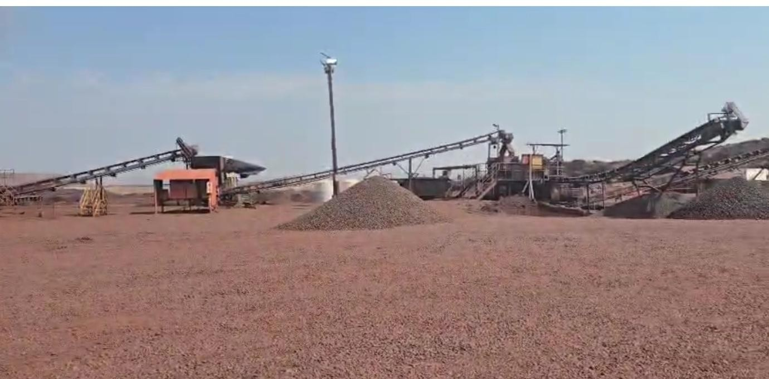
STOCKPILE & OPERATIONS

MATERIAL IRON VISUAL INSPECTION
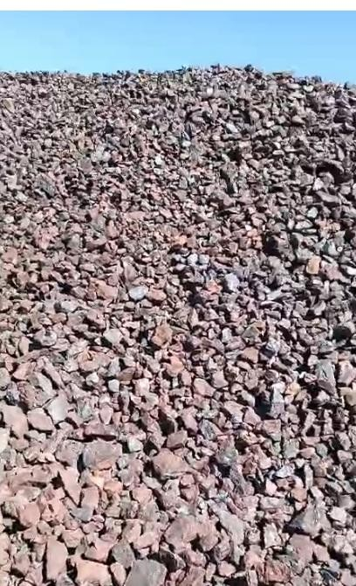

LABORATORY – ASSAY CERTIFICATE (MSK)

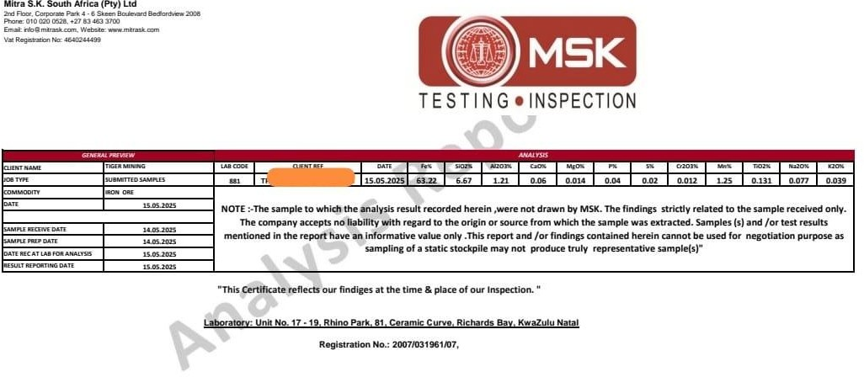

TECHNICAL SPECIFICATIONS (ENHANCED, DETAILED & EXECUTIVE)

Technical Specifications – Iron Ore Fe 62–64%
- Product: High-grade Hematite Iron Ore (Fe 62%–64%), consistent quality validated by independent laboratories (MSK/SGS).

Typical Chemical Profile:
Fe: 62–64%
SiO₂: 5–7%
Al₂O₃: 1.0–1.5%
Moisture: 2–4%
P: <0.06%
S: <0.02%

- Form: Crushed & screened iron ore (10–30 mm typical size), ready for loading.

- Origin: South Africa – Northern Cape region.

- Inspection: SGS / MSK at port of loading.

- Commercial Basis: FOB Saldanha Port, South Africa.

PRICE

Indicative FOB Price Range (Fe 62%-65%
USD 96/MT (fixed range confirmed by assigned producer)

Important Notes:
- This price is indicative only and provided exclusively for evaluation.
- The final FOB price will be confirmed in the Seller SCO after:
✔ LOI/ICPO verification
✔ Buyer company validation
✔ Mutual NDA
- The producer reserves the right to adjust the price based on:
✔ confirmed Fe grade
✔ logistics
✔ vessel ETA
✔ compliance clearance

DELIVERY TERMS (MUCH MORE EXPLANATORY, PROFESSIONAL)

Delivery Terms
- Minimum Order Quantity (MOQ): 150,000 MT per shipment (monthly).

- Availability: Continuous monthly supply based on production allocation and stockpile readiness.
- Logistics: Loading carried out using port-approved conveyor systems or front loaders, depending on vessel requirements.
- Loading Rate: Subject to vessel specifications and port scheduling (average 8,000– 12,000 MT/day).
- Schedule: Shipment dates will be coordinated according to buyer’s vessel ETA and port
availability.

- Packing: Bulk shipment only (no containerized cargo).

- Document Issuance: All export documents, certificates of origin, and lab reports are issued prior to bill of lading.

PAYMENT & FINANCIAL CONDITIONS (ROBUST & EXECUTIVE)

Payment Terms

Accepted Instruments:
✔ Stand-by Letter of Credit (SBLC – irrevocable, transferable, from top global banks)
✔ Cash / TT (case-by-case, subject to enhanced due diligence)

Non-negotiable conditions:
✔ No advance payments
✔ No deposits
✔ No trial shipment required
✔ Full payment guaranteed via SBLC before loading

Banking:
All banking procedures must comply with SWIFT international standards (MT760 / MT799
/ MT103, depending on structure).

CONDITIONS OF SALE (EXPANDED, SERIOUS & TRUST- BUILDING)

Conditions of Sale
- Compliance: Buyer must submit a verifiable LOI or ICPO including full corporate details, banking information, and purchase intent.
- Verification: Seller will provide proof of product (POP) only after validation of buyer credentials and NDAs.
- Quality Assurance: The final payable iron content (Fe%) is determined strictly by SGS/MSK analysis at the port of loading.
- Contract: Annual Supply Agreement (12 months) with renewal options based on performance.

Documentation Provided:
✔ Certificate of Origin
✔ Commercial Invoice
✔ Packing List
✔ SGS/MSK Quality Report
✔ Bill of Lading
✔ Export Permits (when applicable)

Document Version:
Private & Confidential – Not transferable
Digital signature required for validation

Corporate contact Miner Global Connect
⬛vç⬛-† info@minerglobalconnect.com www.minerglobalconnect.com
! +56 9 8891 2564
c… . Monjitas 513, Oficina 11, Santiago, Chile

DOCUMENT CONTROL
This Pre-SCO has been issued exclusively to:
Company: Sadat Traders
Representative: Kamran Murtaza
Date: 27-11-25
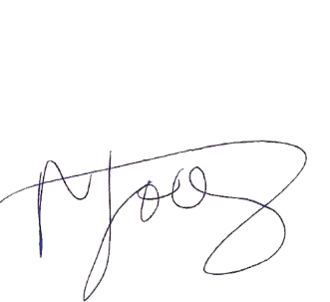
This document is digitally traceable.
Any reproduction, sharing, or disclosure is strictly prohibited and voids validity.
Signature: Robinson Godoy – CEO, Miner Global Connect

______________________________
Robinson Godoy .C
CEO – Miner Global Connect

